**Running Head**

*Functional traits and forest fire regimes*

**Title**

The biogeography of forest fire regimes: a trait-based approach

**Authors**

Jens T. Stevens 1*, 2, Matthew Kling, David Ackerly, Dylan Schwilk, Morgan Varner, Sean Parks

**Author Affiliations and Addresses**

1Department of Environmental Science, Policy and Management, University of California, Berkeley, CA 94720;

*Corresponding Author

**Abstract**

**Introduction**

Mapping of historical and contemporary fire regimes has long been a useful tool to describe spatial variation in characteristic fire behavior across a landscape (Schoennagel and Nelson 2011). Such descriptions are generally based on information regarding historical fire return intervals, climate, predominant vegetation, and biophysical models which link these parameters together (Rollins 2009). Implicit in these models, particularly in forested ecosystems is the recognition that there is variation in a set of functional traits of the predominant vegetation (conifer species) that results in different degrees of resistance to fire among different species (Keeley et al. 2011). However, quantitative variation in these traits has not yet been explicitly linked to variation in fire regimes.

Most conifer species are top-killed by crown fire, and under extreme weather conditions and high fuel loads, the risk of crown fire increases. However, given the inverse relationship between fire frequency and intensity (Steel et al. 2015), tree species that experience more frequent fire have an opportunity to evolve resistance to surface fire (Keeley et al. 2011, Pausas 2015). A set of traits associated with fire resistance that include thick bark, a high degree of self-pruning lower branches, and tall height, have been shown to be correlated with each other, particularly within genera (Schwilk and Ackerly 2001). Bark thickness is particularly associated with tree survival of moderate-intensity surface fires (Hood et al. 2007, Pausas 2015, Pellegrini et al. 2017). Litter flammability traits are also related to fire resistance, as species with shorter flame lengths and longer flame durations are often associated with stand-replacing fire (Schwilk and Caprio 2011), whereas species experiencing with taller flame lengths and shorter flame durations are associated with flashy, “fast-flammable” fire behavior that promotes tree survival (Varner et al. 2015, Pausas et al. 2017). These fire-resisting traits may all be selected for under more frequent fire regimes, whereas species that are less likely to experience fire during their lifetimes, due to a combination of climate and fuel limitation, may have less selective pressure to invest in these strategies (Keeley et al. 2011, Pausas et al. 2017)

It is common practice for species to be ranked on a continuum of “fire tolerance” (Brown and Smith 2000, Safford and Stevens *in press*), but these species descriptions are often based more on a qualitative understanding of species natural history rather than a quantitative assessment of traits that are actually associated with surviving fire. Furthermore, the presence of “fire-intolerant” species in a community is often used to identify areas within a landscape that have likely been fire-free since the establishment of those trees, which can allow inferences of past extent of stand-replacing fire effects in mixed-species stands (Yocom-Kent et al. 2015). Regions dominated by fire-intolerant species are thus presumed to have experienced infrequent, stand-replacing fire historically, while the removal of fire-intolerant species in mixed forests is often an objective of restoration via mechanical methods or prescribed fire (Larson et al. 2013, Safford and Stevens *in press*).

The collective ability of a tree community to survive fire is one indicator of forest resilience to the increase in fire activity that is expected in the future under increased human development and climate change (Johnstone et al. 2016). Past logging practices and increased forest density from fire suppression have profoundly altered forest structure, independent of species composition, in ways that have increased the risk of stand-replacing fire and may overwhelm the adaptations of fire-resistant species within of the community (Millar and Stephenson 2015, Safford and Stevens *in press*). However these historical factors have also shifted species composition in many instances, away from more fire-resistant members of the community (Naficy et al. 2010). It is therefore critical to describe the current condition of forest communities at a landscape scale as a function of their ability to survive fire. Here we illustrate a methodology to quantify the fire resistance of entire forest communities, by integrating functional traits with species distribution and abundance data. We use this approach to highlight important biogeographic variation in likely fire effects across a landscape, to validate other independent spatial metrics of fire regimes, and to identify areas where the current species composition is mismatched with historical fire frequency.

**Methods**

We assembled quantitative trait data on five fire-adaptive traits that contribute to fire resistance of a suite of conifer species. Our trait database included bark thickness, tree height, degree of self-pruning, flame length and flame duration. We estimated the bark thickness of a 25.4 cm (10 in) tree using the species-specific bark thickness multiplier provided in the Fire and Fuels Extension of the Forest Vegetation Simulator (Reinhardt and Crookston 2003). Maximum tree height was derived from the TRY plant trait database (Kattge et al. 2011). Degree of self-pruning was assigned on an ordinal 1-10 scale following the methods and data for genus *Pinus* from Schwilk and Ackerly (2001), supplementing with data for other genera with the Fire Effects and Information System (FEIS 2013). Flammability data on mean flame lengths and flame durations were obtained from Fonda (2001), Fonda et al. (1998), and Banwell and Varner (unpublished data).

We selected conifer tree species based on the species database of the US Forest Service Forest Inventory and Analysis (FIA) National Core Field Guide (USDA Forest Service FIA Program 2014). We identified species classified by FIA as “Western”, with distributions overlapping our eleven-state study area, and that had spatially-explicit basal area data available (see below). Our resulting trait database consisted of 25 widespread conifer species in western North America. Each quantitative trait therefore had a distribution of values across all species in the dataset. We calculated the quantile of a given trait distribution occupied by each species, with the species possessing the most fire-resistant form of the trait assigned a quantile value of 1. We defined the most fire-resistant form of a trait as having the thickest bark, tallest maximum height, greatest degree of self-pruning, tallest flame length (associated with flashy fuels), and shortest flame duration. Finally we averaged the quantile scores for each trait within a given species into a single “fire-resistance score” (FRS), weighting each trait by its relative completeness in our database, so traits with more complete data were counted more heavily in the FRS.

Each species in our traits database had a spatially-explicit interpolated raster of basal area (m2 ha-1) at 250 m resolution, developed by Wilson et al. (2013). These layers are based on imputed basal area per species from FIA plots, based on relationships between basal area and climatic and topographic variables. Validation suggests fairly high accuracy, particularly for widespread species (Riemann et al. 2010, Wilson et al. 2013). We compiled these raster datasets in R using the “raster” package (Hijmans and van Etten 2014). We first identified our area of inference (conifer forests) by calculating the total basal area per pixel of all 25 species in our traits database relative to the total basal area of all other western species, which primarily included hardwoods. We restricted our analysis to only those areas where >50% of the total tree basal area was comprised of species in our traits database. We then estimated the relative basal area fraction of each of our 25 species within each pixel, and multiplied the FRS score of each species by its relative abundance in a given pixel (which could include 0) to derive a community-weighted mean FRS.

We compared the FRS’s to LANDFIRE-derived indices of historical fire regimes, using the fire regime group (FRG) and fire return interval (FRI) layers. FRG and FRI layers were resampled to the same spatial resolution as our FRG data (250 m). The LANDFIRE mean FRI product classifies pixels as having mean fire return intervals within a range of years (e.g. classes of 0-5 years, 6-10 years); we simplified this classification by merging into fewer classes and assigning the median fire return interval of the merged LANDFIRE classes as the pixel value (5, 15, 25,35, 50, 100, 200 and 500 year return intervals). On a random 1% subsample of the full landscape (N=94901), we tested whether different fire regime groups had significantly different fire resistant scores, and whether fire resistance scores decreased as a function of lengthening fire-return intervals.

To quantify potential imbalances between historical fire regimes and current composition, we identify forest areas where the current species composition may be more or less resistant to fire than expected given estimated historical fire frequency. Specifically we sought to identify 1) fire-vulnerable forests with frequent historical fire (“vulnerable-frequent”, 2) fire-vulnerable forests with intermediate historical fire (“vulnerable-intermediate”), 3) fire-resistant forests with intermediate historical fire (“resistant-intermediate”) and 4) fire-resistant forests with infrequent historical fire (“resistant-infrequent”). We defined frequent fire as 1-20 year FRI’s in LANDFIRE, intermediate fire as 41-150 year FRI’s, and infrequent fire as 151-300 year FRI’s. We calculated the FRS percentile of every pixel of a given fire frequency class and identified the 20 percent of pixels on either the fire-resistant or fire-vulnerable tails of the distribution within that fire frequency class.

**Results**

The trait values for our 25 species (Table S1) were significantly correlated among bark thickness, tree height and self-pruning (Fig. S1), but less so amongst flammability traits of flame height and flame duration. Fire-resistance scores ranged from a high of 0.90 for *Sequoia sempervirens* (coast redwood) to a low of 0.13 for *Juniperus occidentalis* (western juniper). Community-weighted mean FRS varied strongly across the landscape (Fig. 1), and were generally consistent with LANDFIRE estimates of fire regime group (Fig. S2) and fire return interval (Fig. S3). FRS was significantly greater in fire regime group 1 (frequent) than either of the other fire regime groups analyzed (Fig. 2), but was greater in fire regime group 5 (infrequent) than in fire regime group 3 (moderately frequent). FRS also decreased significantly with increasing fire return intervals (Fig. 2; t=-54.54, df=134451, P<0.0001). However the median fire resistance score increased in the highest class of fire return intervals (greater than 300 years, classified as 500 years in our regression analysis; Fig. 3).

Within historically frequent fire systems (<20 year return intervals), our approach generally identified forests dominated by *Pinus edulis* grading into *Pinus ponderosa* in the southwest, and California mixed-conifer forests, particularly in the northern part of the state, as having the lowest fire resistance (Fig. 4). Within historically intermediate fire systems (41-150 year return intervals), the most vulnerable forests were generally dominated by a mixture of *Pinus ponderosa* and *Pinus contorta* in eastern Oregon and the Modoc plateau, as well as mixed-conifer forest in the northern Cascade Range in Washington and the southern portions of the Colorado Front Range. Within both intermediate and infrequent fire systems, the most resistant forests were generally dominated by *Pseudotsuga menziesii* and *Tsuga heterophylla*, two dominant and moderately fire-resistant species in the Cascade Range of Oregon and Washington (Fig. 4).

**Discussion**

Points to hit

* Not all frequent-fire forests are the same; some (e.g. Black Hills, Mogollon Rim) are dominated by PIPO much more than others (e.g. Sierra Nevada, Blue mtns), which have a mixture of other species.
* We capture the mid-elevation “sweet spot” for fire (e.g. Sierra Nevada, desert SW, Kaibab plateau): productive forests that can also burn. Fuel limitation below (in pinyon juniper) and climate limitation above (subalpine forests).
* The interesting case of the Cascades, which have more fire-resistant species than the interior rockies and lower elevations of the desert southwest, yet rarely burn because of climate limitation.
* Similar story in redwood forests, which could probably tolerate a lot more fire than they currently do, but again there are climatic limitations there. Redwood region is kind of weird for fire history.
* Limitations: Working with current basal area data; harder to make conclusions about historic fire regimes from this. Less “fire resistant” doesn’t necessarily equate to more high severity fire and vice versa; there are stand replacing components to most fire regimes.

**Figure 1**: Fire resistance scores mapped across the landscape

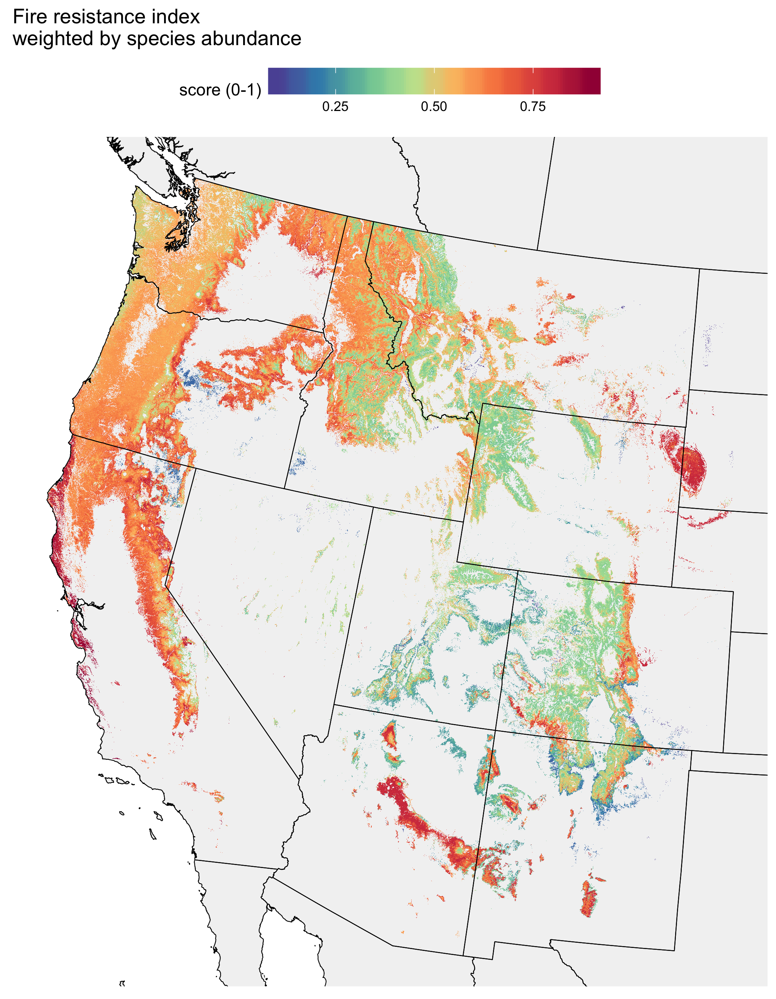

**Figure 2**: Variation in fire regime group as a function of historical fire return intervals.



**Figure 3**: Variation in fire resistance scores as a function of historical fire return intervals.



**Figure 4:** Potential imbalances between fire resistance traits and historical fire regimes. “Resistant” areas are defined as the 20% of forested areas with the highest fire resistance scores in areas defined as either intermediate (41-150 year) or infrequent (151-300 year) historical fire return intervals. “Vulnerable” areas are defined as the 20% of forested areas with the lowest fire resistance scores in areas defined as either intermediate or frequent (<20 year) historical fire return intervals.

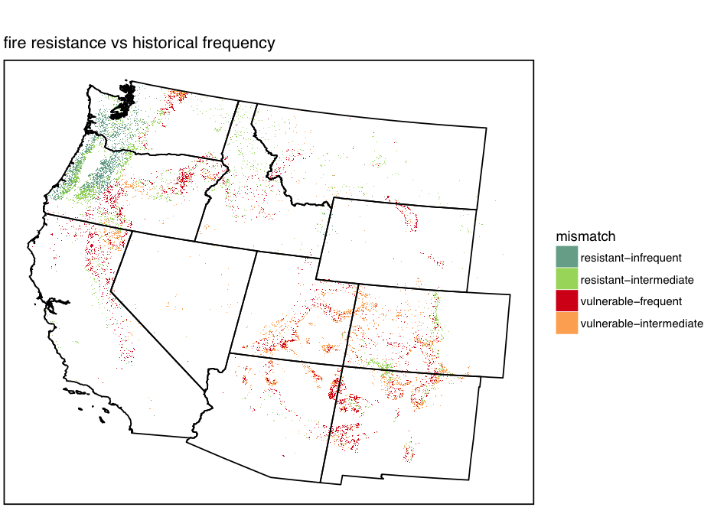

**Literature Cited**

Brown, J. K., and J. K. Smith. 2000. Wildland fire in ecosystems: effects of fire on flora. Ogden, UT: U.S. Department of Agriculture, Forest Service, Rocky Mountain Research Station.

FEIS. 2013. Fire Effects Information System. Plant species descriptions., USDA Forest Service, Rocky Mountain Research Station, Fire Sciences Laboratory, Missoula MT.

Fonda, R. W. 2001. Burning Characteristics of Needles from Eight Pine Species. Forest Science **47**:390-396.

Fonda, R. W., L. A. Belanger, and L. L. Burley. 1998. Burning characteristics of western conifer needles. Northwest Science **72**:1-9.

Hijmans, R., and J. van Etten. 2014. raster: Geographic data analysis and modeling. R package version **517**:2.2-12.

Hood, S. M., C. W. McHugh, K. C. Ryan, E. Reinhardt, and S. L. Smith. 2007. Evaluation of a post-fire tree mortality model for western USA conifers. International Journal of Wildland Fire **16**:679-689.

Johnstone, J. F., C. D. Allen, J. F. Franklin, L. E. Frelich, B. J. Harvey, P. E. Higuera, M. C. Mack, R. K. Meentemeyer, M. R. Metz, G. L. W. Perry, T. Schoennagel, and M. G. Turner. 2016. Changing disturbance regimes, ecological memory, and forest resilience. Frontiers in Ecology and the Environment **14**:369-378.

Kattge, J., S. Díaz, S. Lavorel, I. C. Prentice, P. Leadley, G. Bönisch, E. Garnier, M. Westoby, P. B. Reich, I. J. Wright, J. H. C. Cornelissen, C. Violle, S. P. Harrison, P. M. Van Bodegom, M. Reichstein, B. J. Enquist, N. A. Soudzilovskaia, D. D. Ackerly, M. Anand, O. Atkin, M. Bahn, T. R. Baker, D. Baldocchi, R. Bekker, C. C. Blanco, B. Blonder, W. J. Bond, R. Bradstock, D. E. Bunker, F. Casanoves, J. Cavender-Bares, J. Q. Chambers, F. S. Chapin, J. Chave, D. Coomes, W. K. Cornwell, J. M. Craine, B. H. Dobrin, L. Duarte, W. Durka, J. Elser, G. Esser, M. Estiarte, W. F. Fagan, J. Fang, F. Fernández-Méndez, A. Fidelis, B. Finegan, O. Flores, H. Ford, D. Frank, G. T. Freschet, N. M. Fyllas, R. V. Gallagher, W. A. Green, A. G. Gutierrez, T. Hickler, S. I. Higgins, J. G. Hodgson, A. Jalili, S. Jansen, C. A. Joly, A. J. Kerkhoff, D. Kirkup, K. Kitajima, M. Kleyer, S. Klotz, J. M. H. Knops, K. Kramer, I. Kühn, H. Kurokawa, D. Laughlin, T. D. Lee, M. Leishman, F. Lens, T. Lenz, S. L. Lewis, J. Lloyd, J. Llusià, F. Louault, S. Ma, M. D. Mahecha, P. Manning, T. Massad, B. E. Medlyn, J. Messier, A. T. Moles, S. C. Müller, K. Nadrowski, S. Naeem, Ü. Niinemets, S. Nöllert, A. Nüske, R. Ogaya, J. Oleksyn, V. G. Onipchenko, Y. Onoda, J. Ordoñez, G. Overbeck, W. A. Ozinga, S. Patiño, S. Paula, J. G. Pausas, J. Peñuelas, O. L. Phillips, V. Pillar, H. Poorter, L. Poorter, P. Poschlod, A. Prinzing, R. Proulx, A. Rammig, S. Reinsch, B. Reu, L. Sack, B. Salgado-Negret, J. Sardans, S. Shiodera, B. Shipley, A. Siefert, E. Sosinski, J. F. Soussana, E. Swaine, N. Swenson, K. Thompson, P. Thornton, M. Waldram, E. Weiher, M. White, S. White, S. J. Wright, B. Yguel, S. Zaehle, A. E. Zanne, and C. Wirth. 2011. TRY – a global database of plant traits. Global Change Biology **17**:2905-2935.

Keeley, J. E., J. G. Pausas, P. W. Rundel, W. J. Bond, and R. A. Bradstock. 2011. Fire as an evolutionary pressure shaping plant traits. Trends in Plant Science **16**:406-411.

Larson, A. J., R. T. Belote, C. A. Cansler, S. A. Parks, and M. Dietz. 2013. Latent Resilience in Ponderosa Pine Forest: Effects of Resumed Frequent Fire. Ecological Applications.

Millar, C. I., and N. L. Stephenson. 2015. Temperate forest health in an era of emerging megadisturbance. Science **349**:823-826.

Naficy, C., A. Sala, E. G. Keeling, J. Graham, and T. H. DeLuca. 2010. Interactive effects of historical logging and fire exclusion on ponderosa pine forest structure in the northern Rockies. Ecological Applications **20**:1851-1864.

Pausas, J. G. 2015. Bark thickness and fire regime. Functional Ecology **29**:315-327.

Pausas, J. G., J. E. Keeley, and D. W. Schwilk. 2017. Flammability as an ecological and evolutionary driver. Journal of Ecology **105**:289-297.

Pellegrini, A. F. A., W. R. L. Anderegg, C. E. T. Paine, W. A. Hoffmann, T. Kartzinel, S. S. Rabin, D. Sheil, A. C. Franco, and S. W. Pacala. 2017. Convergence of bark investment according to fire and climate structures ecosystem vulnerability to future change. Ecology Letters **20**:307-316.

Reinhardt, E. D., and N. L. Crookston. 2003. The Fire and Fuels Extension to the Forest Vegetation Simulator. USDA Forest Service Gen. Tech. Rep. RMRS-GTR-116, Ogden, UT.

Riemann, R., B. T. Wilson, A. Lister, and S. Parks. 2010. An effective assessment protocol for continuous geospatial datasets of forest characteristics using USFS Forest Inventory and Analysis (FIA) data. Remote Sensing of Environment **114**:2337-2352.

Rollins, M. G. 2009. LANDFIRE: a nationally consistent vegetation, wildland fire, and fuel assessment. International Journal of Wildland Fire **18**:235-249.

Safford, H. D., and J. T. Stevens. *in press*. Natural Range of Variation (NRV) for yellow pine and mixed conifer forests in the Sierra Nevada, southern Cascades, and Modoc and Inyo National Forests, California, USA. USDA Forest Service, Pacific Southwest Research Station. General Technical Report PSW-GTR-___, Albany, CA.

Schoennagel, T., and C. R. Nelson. 2011. Restoration relevance of recent National Fire Plan treatments in forests of the western United States. Frontiers in Ecology and the Environment **9**:271-277.

Schwilk, D. W., and D. D. Ackerly. 2001. Flammability and serotiny as strategies: correlated evolution in pines. Oikos **94**:326-336.

Schwilk, D. W., and A. C. Caprio. 2011. Scaling from leaf traits to fire behaviour: community composition predicts fire severity in a temperate forest. Journal of Ecology **99**:970-980.

Steel, Z. L., H. D. Safford, and J. H. Viers. 2015. The fire frequency-severity relationship and the legacy of fire suppression in California forests. Ecosphere **6**:art8.

USDA Forest Service FIA Program. 2014. Forest Inventory and Analysis National Core Field Guide. [http://www.fia.fs.fed.us/library/field-guides-methods-proc/docs/2014/Core FIA field guide_6-1.pdf](http://www.fia.fs.fed.us/library/field-guides-methods-proc/docs/2014/Core%20FIA%20field%20guide_6-1.pdf)

Varner, J. M., J. Kane, J. Kreye, and E. Engber. 2015. The Flammability of Forest and Woodland Litter: a Synthesis. Current Forestry Reports:1-9.

Wilson, B. T., A. J. Lister, R. I. Riemann, and D. M. Griffith. 2013. Live tree species basal area of the contiguous United States (2000-2009).*in* R. M. R. S. USDA Forest Service, editor., Newtown Square, PA.

Yocom-Kent, L. L., P. Z. Fulé, W. A. Bunn, and E. G. Gdula. 2015. Historical high-severity fire patches in mixed-conifer forests. Canadian Journal of Forest Research:1587-1596.

**Supplementary Tables and Figures**

**Table S1**: Trait data and fire resistance scores (FRS) for species used in the analysis. Bark thickness multipliers were set to NA for both species of *Tsuga*.

|  |  |  |  |  |  |  |  |  |  |  |  |  |  |  |
| --- | --- | --- | --- | --- | --- | --- | --- | --- | --- | --- | --- | --- | --- | --- |
|  | Values | | | | | |  | Quantiles | | | | | |  |
| Scientific_Name | Bark thickness | Plant height | Self pruning | Flame duration | Flame ht | Percent consumed |  | Bark thickness | Plant height | Self pruning | Flame duration | Flame ht | Percent consumed | FRS |
| Sequoia_sempervirens | 2.06 | 95.17 | 5.00 | 73.40 | 59.40 | 86.10 | 1.00 | 1.00 | 1.00 | 0.77 | 0.93 | 0.80 | 0.87 | 0.91 |
| Pinus_jeffreyi | 1.73 | 51.42 | 10.00 | 79.20 | 67.30 | 90.00 | 0.81 | 0.81 | 0.76 | 1.00 | 0.87 | 0.87 | 0.93 | 0.87 |
| Larix_occidentalis | 1.60 | 51.10 | 10.00 | NA | NA | NA | 0.78 | 0.78 | 0.66 | 1.00 | NA | NA | NA | 0.80 |
| Pinus_lambertiana | 1.83 | 62.29 | 10.00 | 128.50 | 55.60 | 77.10 | 0.89 | 0.89 | 0.93 | 1.00 | 0.33 | 0.67 | 0.67 | 0.80 |
| Pinus_ponderosa | 1.60 | 41.23 | 10.00 | 79.70 | 77.00 | 92.00 | 0.78 | 0.78 | 0.45 | 1.00 | 0.80 | 1.00 | 1.00 | 0.80 |
| Sequoiadendron_giganteum | 2.06 | 85.58 | 8.00 | 148.50 | 42.60 | 75.80 | 1.00 | 1.00 | 0.97 | 0.85 | 0.27 | 0.47 | 0.60 | 0.76 |
| Pinus_monticola | 0.89 | 62.13 | 6.00 | 90.29 | 75.14 | 82.78 | 0.37 | 0.37 | 0.90 | 0.81 | 0.60 | 0.93 | 0.80 | 0.72 |
| Calocedrus_decurrens | 1.79 | 48.08 | 5.00 | NA | NA | NA | 0.85 | 0.85 | 0.55 | 0.77 | NA | NA | NA | 0.72 |
| Abies_procera | 1.14 | 55.12 | 5.00 | NA | NA | NA | 0.52 | 0.52 | 0.83 | 0.77 | NA | NA | NA | 0.71 |
| Chamaecyparis_lawsonia | 2.06 | 50.00 | 3.00 | NA | NA | NA | 1.00 | 1.00 | 0.62 | 0.35 | NA | NA | NA | 0.66 |
| Abies_grandis | 1.17 | 59.43 | 4.00 | NA | NA | NA | 0.56 | 0.56 | 0.86 | 0.46 | NA | NA | NA | 0.63 |
| Pseudotsuga_menziesii | 1.60 | 54.26 | 5.00 | 105.80 | 26.20 | 26.60 | 0.78 | 0.78 | 0.79 | 0.77 | 0.47 | 0.20 | 0.20 | 0.61 |
| Abies_amabilis | 1.19 | 51.27 | 5.00 | 79.80 | 38.40 | 32.00 | 0.59 | 0.59 | 0.72 | 0.77 | 0.73 | 0.27 | 0.27 | 0.60 |
| Abies_magnifica | 0.99 | 46.79 | 5.00 | NA | NA | NA | 0.44 | 0.44 | 0.52 | 0.77 | NA | NA | NA | 0.57 |
| Thuja_plicata | 0.89 | 51.19 | 5.00 | 113.20 | 42.40 | 45.70 | 0.37 | 0.37 | 0.69 | 0.77 | 0.40 | 0.40 | 0.33 | 0.53 |
| Abies_concolor | 1.22 | 46.31 | 4.00 | NA | NA | NA | 0.63 | 0.63 | 0.48 | 0.46 | NA | NA | NA | 0.52 |
| Tsuga_mertensiana | *5.59* | 25.00 | 5.00 | NA | NA | NA | NA | NA | 0.24 | 0.77 | NA | NA | NA | 0.49 |
| Tsuga_heterophylla | *4.95* | 48.13 | 4.00 | 68.40 | 24.60 | 18.80 | NA | NA | 0.59 | 0.46 | 1.00 | 0.13 | 0.07 | 0.47 |
| Pinus_contorta | 0.71 | 26.06 | 3.00 | 101.18 | 58.14 | 79.87 | 0.22 | 0.22 | 0.28 | 0.35 | 0.53 | 0.73 | 0.73 | 0.42 |
| Picea_engelmannii | 0.91 | 37.19 | 2.00 | NA | NA | NA | 0.41 | 0.41 | 0.41 | 0.27 | NA | NA | NA | 0.37 |
| Abies_lasiocarpa | 1.04 | 27.41 | 2.00 | 79.80 | 16.70 | 25.60 | 0.48 | 0.48 | 0.34 | 0.27 | 0.73 | 0.07 | 0.13 | 0.35 |
| Pinus_flexilis | 0.76 | 17.14 | 2.00 | 154.57 | 55.29 | 71.70 | 0.30 | 0.30 | 0.17 | 0.27 | 0.20 | 0.60 | 0.53 | 0.31 |
| Pinus_edulis | 1.57 | 13.53 | 1.00 | 253.86 | 40.00 | 62.20 | 0.67 | 0.67 | 0.07 | 0.08 | 0.07 | 0.33 | 0.40 | 0.27 |
| Pinus_albicaulis | 0.76 | 17.59 | 1.00 | 182.86 | 48.43 | 63.40 | 0.30 | 0.30 | 0.21 | 0.08 | 0.13 | 0.53 | 0.47 | 0.26 |
| Picea_sitchensis | 0.69 | 27.08 | 2.00 | NA | NA | NA | 0.19 | 0.19 | 0.31 | 0.27 | NA | NA | NA | 0.26 |
| Chamaecyparis_nootkatensis | 0.56 | 35.44 | NA | NA | NA | NA | 0.04 | 0.04 | 0.38 | NA | NA | NA | NA | 0.21 |
| Juniperus_occidentalis | 0.64 | 15.87 | 2.00 | NA | NA | NA | 0.15 | 0.15 | 0.10 | 0.27 | NA | NA | NA | 0.17 |
| Picea_glauca | 0.64 | 16.26 | NA | NA | NA | NA | 0.15 | 0.15 | 0.14 | NA | NA | NA | NA | 0.14 |
| Juniperus_scopulorum | 0.64 | 11.58 | NA | NA | NA | NA | 0.15 | 0.15 | 0.03 | NA | NA | NA | NA | 0.09 |

**Fig. S1**: Correlations between traits.



**Fig. S2**: **Fire regime groups from LANDFIRE.** Groups 2 and 4 were masked to NA values (white)

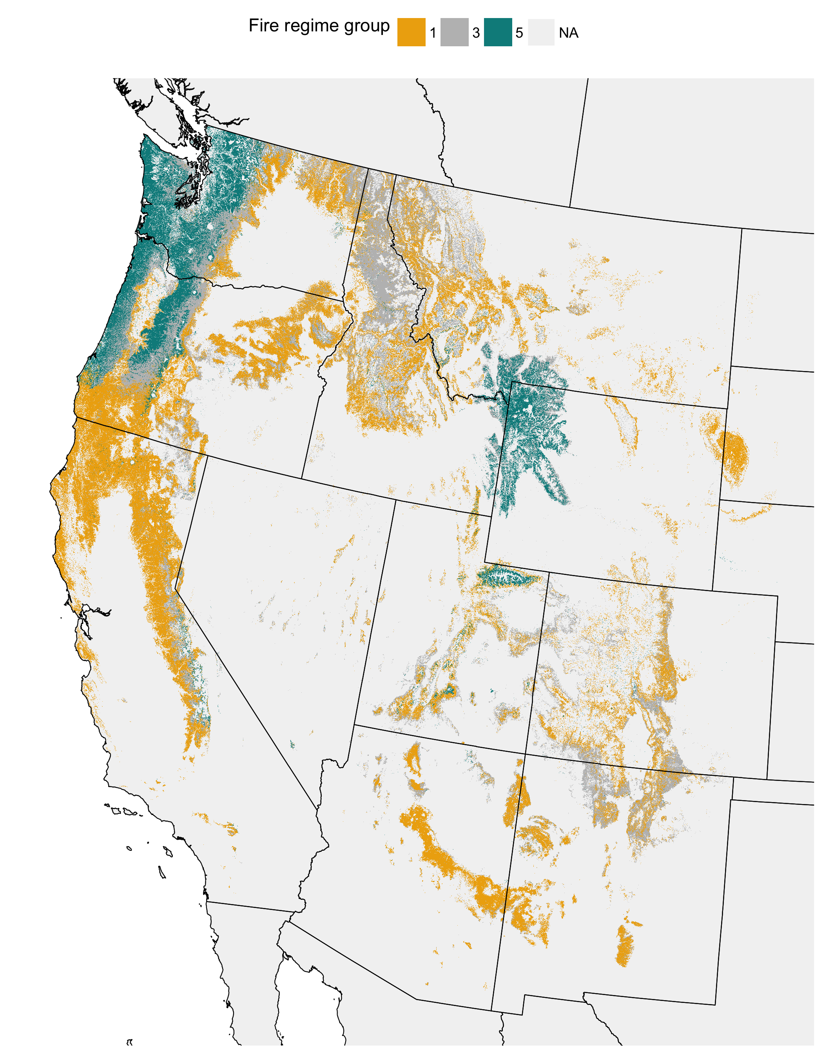

**Fig. S3: Fire return interval from LANDFIRE**

